Laptop Issues

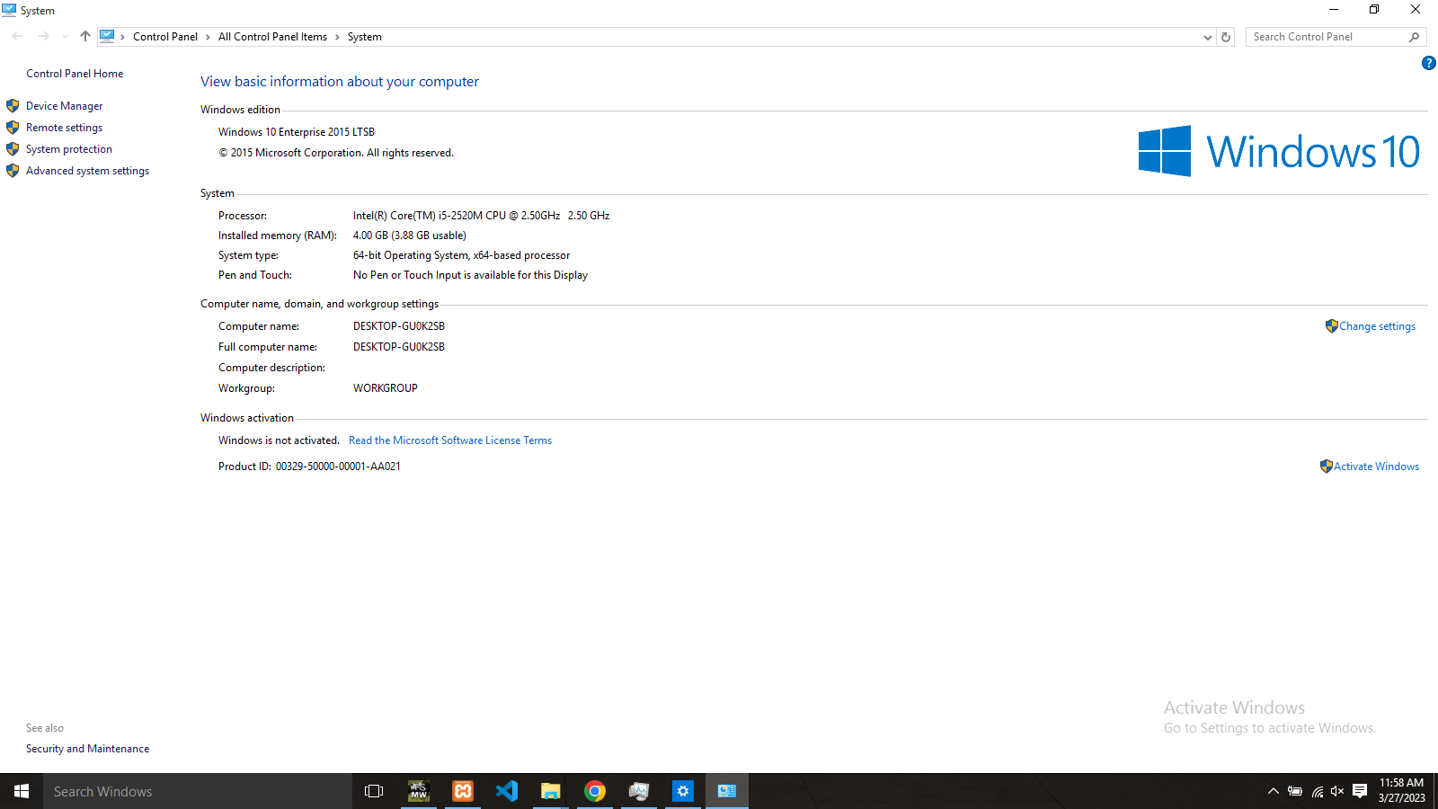

Name | Problems
Katlego  Bonolo  Kholophelo  Samke | Laptop only works with a power supply. Loadshedding switches laptop off.

